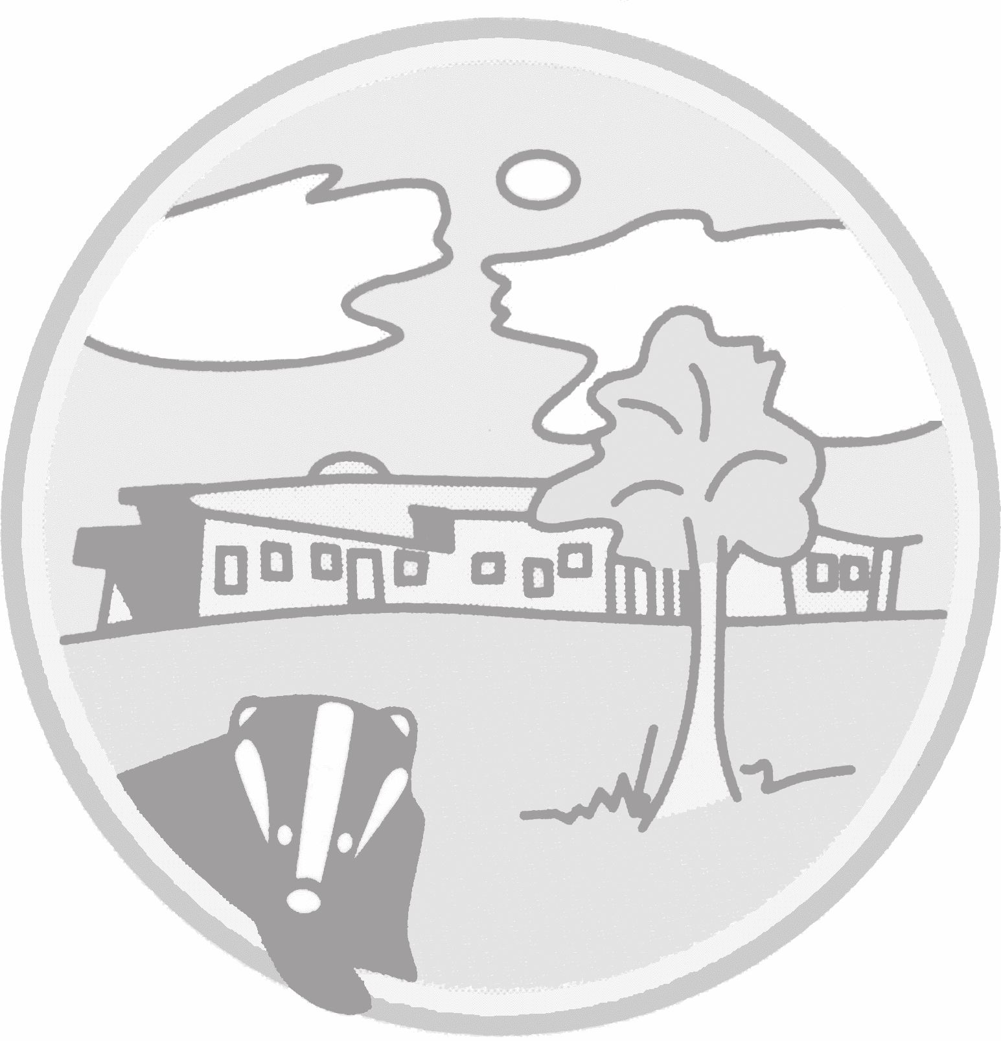

Year A – Keep me safe

Protective Behaviours

Year A – Keep me safe

Protective Behaviours

Year A – Keep me healthy

Physical Fitness and Diet

Year A – Keep me healthy

Physical health

Year A – Keep me happy

Respectful relationships

Year A – Keep me happy

Mental health

Year A – Keep me safe

Safe relationships

Year B – Keep me healthy

Physical Fitness and Diet

Year B – Keep me healthy

Physical health

Year B – Keep me happy

Respectful relationships

Year B – Keep me happy

Mental health

Year B – Keep me safe

Safe relationships

Year B – Keep me safe

Protective Behaviours

**YEAR 1 and 2**

Year A – Keep me healthy

Physical Fitness and Diet

Year A – Keep me healthy

Physical health

Year A – Keep me happy

Respectful relationships

Year A – Keep me happy

Mental health

Year A – Keep me safe

Safe relationships

Year B – Keep me healthy

Physical Fitness and Diet

Year B – Keep me healthy

Physical health

Year B – Keep me happy

Respectful relationships

Year B – Keep me happy

Mental health

Year B – Keep me safe

Safe relationships

Year B – Keep me safe

Protective Behaviours

**YEAR 3 and 4**

**YEAR 5 and 6**

Year B – Keep me healthy

Physical Fitness and Diet

Year B – Keep me healthy

Physical health

Year B – Keep me happy

Respectful relationships

Year B – Keep me happy

Mental health

Year B – Keep me safe

Safe relationships

Year B – Keep me safe

Protective Behaviours

Year A – Keep me healthy

Physical Fitness and Diet

Year A – Keep me healthy

Physical health

Year A – Keep me happy

Respectful relationships

Year A – Keep me happy

Mental health

Year A – Keep me safe

Safe relationships

Year A – Keep me safe

Protective Behaviours